Academy of Emergency Medicine – Akadémia Urgentnej Medicíny
Pernek 141, 900 53, Pernek, Slovak Republic
+421903740712, +421915434784
info@academyofemergencymedicine.sk
www.academyofemergencymedicine.sk

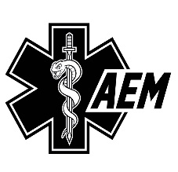
WITHDRAWAL FROM CONTRACT FORM
Online Store https://www.academyofemergencymedicine.sk/
(Please complete and send this form only if you wish to withdraw from the contract)

– To: Akadémia Urgentnej Medicíny - Academy of Emergency Medicine,
900 53 Pernek 141, Pernek, Slovak Republic in written (hard copy) form or by email to: store@academyofemergencymedicine.sk

– I/We hereby give notice that I/We withdraw from the contract for the following goods / from the contract for the provision of the following service*:

– Date of order / Date of receipt*:

– Name and surname of the Consumer(s)*:

– Address of the Consumer(s)*:

– Email and telephone contact of the Consumer(s)*:

– Bank account number of the Consumer(s)* to which the refunded amount is to be transferred:

– Signature of the Consumer(s)* (only if this form is submitted in paper form)

.......................................

– Date:

* Delete as appropriate.

